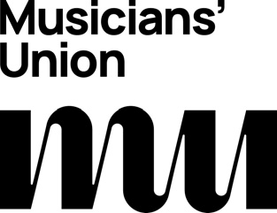
Access Rider
for disabled musicians, performers, artists,
composers, and technical staﬀ in venues.
*Please do not share this document without my prior consent
Introduction
My access needs

Emergency information
Further information

