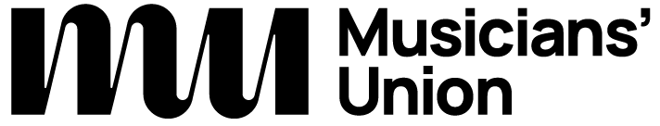 

Access Rider

for disabled musicians, performers, artists, composers, and technical staff in venues

Please do not share this document without my prior consent

Introduction

My access needs

Emergency information

Further information

Find out more about how to use the Access Rider template along with examples and alternative formats: [theMU.org/accessrider](https://theMU.org/accessrider).